Creative Technologies Project: Gamifying a Health and Fitness App for Young Adults – Research Report

**Author Name**Michael Ratcliffe

Michael2.ratcliffe@live.uwe.ac.uk

Supervisor: Lloyd Savickas

Department of Computer Science and Creative Technology

University of the West of England  
Coldharbour Lane  
Bristol BS16 1QY

**Research Report**

**Abstract**

This is a research report on what lifestyle choices and habits can improve mental health and general fitness in young adults, and how these choices and habits can be encouraged through a gamified application.

It also explores the benefits of using gamification methods versus traditional design methods when creating apps.

**Keywords**: gamification, apps, health,

**1. Introduction**

The aim of this project is to explore game design methods that could encourage activities and habits which benefit mental health and general fitness for users, with the end goal of creating an gamified application (app/s).

**Research Aims**

* Find out what key factors encourage people to use apps and identify which ones are relevant to this project
* Investigate gamification techniques and their effect on user motivation in apps
* To research what activities and personal habits are proven to help improve:
  + mental health in young adults
  + general fitness in young adults

**2. Research methods**

Mental health is a serious issue amongst young people (McManus S, et al,. 2016)) and thus there has been a lot of research done into the causes of mental health problems as well as the links between mental health and smartphone use.

As well as this, due to the huge market potential of smartphone apps (over $365 billion in 2018 (Clement, J. 2019)), there has been significant research undertaken into design methods that motivate people to use apps and retain them. This is helpful as it will be easy to find methods that are relevant to this project.

There may be some bias in the research found, as the research into game design methods do not consider any negative psychological effects on users that may occur as a result of the use of these methods such as gaming addiction (Pontes et al., 2019). The research in this report is taken from a wide range of sources, but is mainly secondary data from journals, papers and books.

**3. Research findings**

In order to work out what behaviours to encourage through the use of a gamified app it is important to identify habits and lifestyle choices that benefit fitness and mental health. One study was particularly useful as it researched specifically what lifestyle choices affected mental health and general fitness in young adults and students (Velten *et al.*, 2018). From this study, 4 key lifestyle choices can be identified that contribute to good mental health as well as general fitness.

These lifestyle choices are:

* Body mass index – study shows that obesity has strong links to poor mental health (Velten et al,. 2018)
* Physical exercise – the act of exercising was identified as a protective factor which negates the risk of developing symptoms of depression. (Mammen and Faulkner, 2013)
* Mental activities – brain receptive and creative activities such as visiting the theatre or playing an instrument reduce symptoms of anxiety and depression (Velten et al,. 2018)
* Sleep – sleep disturbances contribute to illnesses such as schizophrenia, bipolar disorder and depression (Jagannath, Peirson and Foster, 2013)
* Social irregularity – loneliness can often be caused by social isolation and has strong links to depression (Matthews et al,. 2016)

There are many popular apps which motivate users to fulfil these lifestyle choices; such as fitness apps which make up the 9th largest category of apps (Statista, 2019) and sleep apps which have been used by 15% of young adults in the US (Statista 2017).

Although encouraging behaviours such as physical exercise is inherently a good thing, there are some drawbacks about the motivational methods used in currently available apps.

A study into concerns around the usage of ‘self-tracking’ fitness apps such as Strava and MyFitnessPal by young people (18 – 25) (Honary *et al.*, 2019) identified negative feelings experienced by people using said apps. These include: guilt around not meeting assigned goals, social isolation and lack of autonomy during use of the app.

The apps used by participants in the study promote similar behaviours that would be replicated (e.g. healthy eating) in a gamified project at the end of this project, but it is important to consider the negative feelings that users experienced and make efforts to avoid them. Users provided reasons they stopped using apps, which can be seen in the table below.

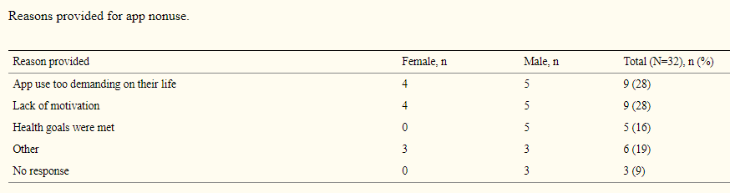

Table Reasons for non use of fitness apps (Honary et al., 2019)

One way of avoiding the issue of fitness apps being ‘too demanding’ and address the lack of motivation to use these apps could be to utilise motivational techniques found in gamification methods. Gamification is ‘the craft of deriving all the fun and engaging elements found in games and applying them to real-world or productive activities’ (Chou, Y. 2015).

According to Self Determination Theory (Ryan and Deci, 2000), people are motivated to play games is that games fulfil certain psychological needs; one of which is the need for control (autonomy) in one’s actions (Ryan, R. et al,. 2006). As players voluntarily choose to play games (R, Bartle. 2004), there is a high sense of autonomy and therefore more motivation to play. It could be argued that if a fitness app were to utilise design methods found in games, it would reduce the feeling of lack of autonomy and increase motivation to use the apps.

One of the other needs that people play games to fulfil is relatedness, the need to feel to ‘connected with others’ (Ryan, R. et al,. 2006). As seen in the study into fitness apps, some users reported feelings of social isolation (Honory et al., 2019) as a result of using the app and consequently were not motivated to continue using it. It could be argued that these feelings were a result of the apps’ inability to fulfil the need for relatedness.

One possible way of fulfilling the need to relate is the use of virtual avatars. One technique used in apps such as Duolingo is a virtual avatar that can be customised by the player (by purchasing cosmetic items with virtual currency), which adds a level of personalisation. Research has shown that if a user identifies with an avatar in a game, they will devote more time, energy and emotion to the game (Zhong, Z. Yao, M. 2013). Using an avatar in an app could motivate users to use the app more.

When thinking about implementation in future, it is important to consider the success of other apps which use gamification techniques and if there are similar to the app this project will hopefully result in.

This table shows a few popular apps which use gamification methods.

|  |  |  |  |
| --- | --- | --- | --- |
| Application | Total Users (approx) | Type | Gamification methods |
| Duolingo | 300,000,000 (Lardinois, F 2018) | Education | Streaks, point system, avatar, micro/macro goals |
| Headspace | 31,000,000 (Perez, S 2018) | Health and Fitness, Sleep | External triggers, social integration, progress tracking (points/milestones) |
| Calorie Counter – MyFitnessPal (MFP) | 120,000,000+ (Perez, S 2015) | Health and Fitness | Micro/macro goals, progress tracking (points) social integration |

Methods Summary:

* An example of a point system is when apps or games give users something which has a value inside the game as a reward for meeting certain requirements. Common examples are experience (xp) points which is given for progress in the game and virtual currencies (fig1) that can be spent on virtual items such as cosmetics for a user’s avatar.
* Streaks reward users with points for continued use. A common example is giving a user points if they use an app or log in to a website every day(fig2).
* Duolingo uses micro and macro goals to teach languages. The user is presented with a long term goal (e.g. mastering French) and lots of smaller goals (e.g. learning French verbs). The smaller achievements keep the user motivated with the larger goal insight.
* An example of social integration is a user being able to compare their points or progress with their friends via social media platforms such as Facebook or Twitter.
* External triggers are used in apps to remind users about a task or goal. These can include push notifications on mobile devices and emails.

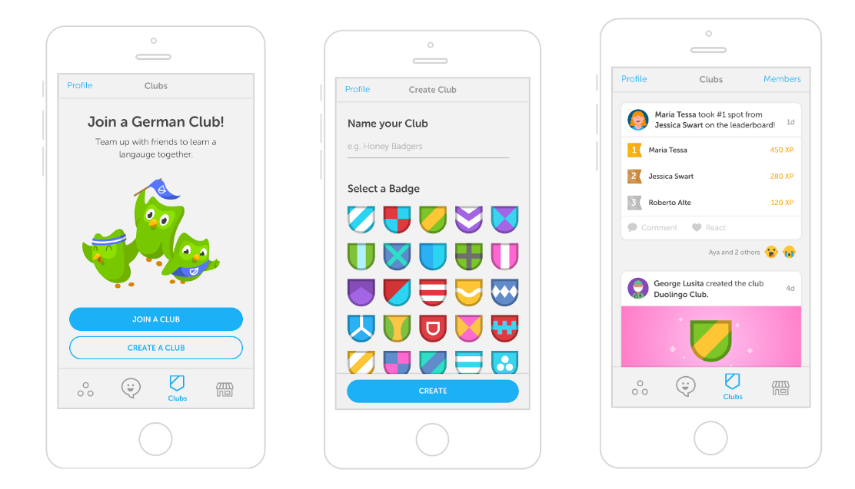

*Example of social integration (Duolingo 2019)*

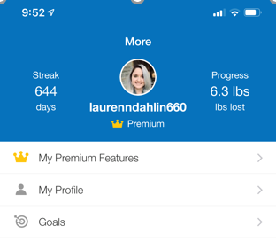

*Figure 2 example of a streak (MFP 2019)*

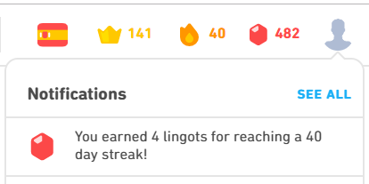

Figure example of an in-game currency point system (Duolingo 2019)

Previous studies have already shown that gamification techniques can have positive effects on health and fitness. One study (Jones *et al.*, 2014) conducted in a primary school in the USA helped children eat more fruit and vegetables through a co-operative game. The key techniques used in this study were a compelling narrative, virtual currency and in-game rewards and performance adapted goals. These techniques are widely used in gamification. The virtual currency and in-game rewards are examples of a point system and virtual economy, common motivational techniques used in video games (Gabe, Z. Cunningham, C. 2011), and the compelling narrative helps fulfil the need for relatedness (Sailer *et al.*, 2017).

**4. Conclusion and recommendations**

It can be drawn from the research presented that the key habits to encourage for good mental health and general fitness are:

* Physical exercise
* Good sleep patterns
* Social activities

This project will prove that the above can be achieved in an app by using game design methods. By using gamification methods compared to traditional app design methods, the risk of users not feeling motivated to use the app or experiencing negative feelings while trying to maintain these habits is reduced. It is clear from examining other apps that the essential features an app would need to keep users motivated to play are:

* A points system i.e. virtual currency or in game rewards
* Social integration through either: a leaderboard, groups, a virtual avatar or a compelling narrative.
* Micro/macro achievements – long term goals made up of small achievable tasks.

**5. References**

Bartle, R. (2004) *Designing Virtual Worlds*. Berkeley, Calif: New Riders

Chou, Y. 2015 Octalysis – The Complete Gamification framework

Clement, J. (2019) Worldwile mobile app revenues in 2014 – 2023.

<https://www.statista.com/statistics/269025/worldwide-mobile-app-revenue-forecast/>

Duolingo, Inc (2019) Duolingo (2019)– Available from: <https://www.duolingo.com> [Accessed 08/12/19]

Google Play Store – Google 2019

Headspace (2019) Headspace (2019) – Available from <https://www.headspace.com> [Accessed 08/12/19]

Honary, M., Bell, B.T., Clinch, S., Wild, S.E. and McNaney, R. (2019) Understanding the Role of Healthy Eating and Fitness Mobile Apps in the Formation of Maladaptive Eating and Exercise Behaviours in Young

People. *JMIR mHealth and uHealth* [online]. 7 (6), pp.e14239.

Jagannath, A., Peirson, S. N. and Foster, R. G. (2013) Sleep and circadian rhythm disruption in neuropsychiatric illness. *Current Opinion in Neurobiology* [online]. 23(5), pp. 888-894.

Jones, B.A., Madden, G.J., Wengreen, H.J., Aguilar, S.S. and Desjardins, E.A. (2014) Gamification of Dietary Decision-Making in an Elementary-School Cafeteria. *Plos One* [online]. 9 (4), pp.e93872.

Mammen, G. and Faulkner, G. (2013) Physical Activity and the Prevention of Depression: A Systematic Review of Prospective Studies. *American Journal of Preventive Medicine*. 45(5), pp. 649-657.

Matthews, T., Danese, A., Wertz, J., Odgers, C.L., Ambler, A., Moffitt, T.E. and Arseneault, L. (2016) Social isolation, loneliness and depression in young adulthood: a behavioural genetic analysis. *Social Psychiatry and Psychiatric Epidemiology* [online]. 51 (3), pp.339-348.

McManus S, Bebbington P, Jenkins R, Brugha T. (eds.) (2016) Mental health and wellbeing in England: Adult Psychiatric Morbidity Survey 2014. Leeds: NHS Digital [Online] Available from <https://files.digital.nhs.uk/pdf/q/3/mental_health_and_wellbeing_in_england_full_report.pdf> [accessed 05/12/19]

MyFitnessPal, Inc. (2019) Calorie Counter – MyFitnessPal (2019) – Available from <https://www.myfitnesspal.com> [Accessed 08/12/19]

Perez, S. and Lunden, I. (2018) *Meditation App Headspace Bets on Voice and AI with Alpine.AI Acquisition.*Available from: <https://techcrunch.com/2018/09/04/meditation-app-headspace-bets-on-voice-and-a-i-with-alpine-ai-acquisition/> [Accessed 08/12/19].

Perez, S. (2015) Under Armour Snatches Up Health And Fitness Trackers Endomondo And MyFitnessPal. Available from <https://techcrunch.com/2015/02/04/athletic-apparel-company-under-armour-snatches-up-health-and-fitness-trackers-endomondo-and-myfitnesspal/> [Accessed 08/12/19]

Pontes, H.M., Schivinski, B., Sindermann, C., Li, M., Becker, B., Zhou, M. and Montag, C. (2019) Measurement and Conceptualization of Gaming Disorder According to the World Health Organization Framework: the Development of the Gaming Disorder Test. *International Journal of Mental Health and Addiction* [online].

Ryan, R.M. and Deci, E.L. (2000) Self-determination theory and the facilitation of intrinsic motivation, social development, and well-being. *The American Psychologist*. 55 (1), pp.68-78.

Ryan, R.M., Rigby, C.S. and Przybylski, A. (2006) The Motivational Pull of Video Games: A Self-Determination Theory Approach. *Motivation and Emotion*. 30 (4), pp.344-360.

Statista 2019 – Most popular Apple App Store categories in November 2019.

<https://www.statista.com/statistics/270291/popular-categories-in-the-app-store/>

Statista 2017 – Percentage of U.S. adults that use apps to track their sleep

<https://www.statista.com/statistics/699439/us-adults-that-use-apps-to-track-sleep-by-age/>

Velten, J., Bieda, A., Scholten, S., Wannemüller, A. and Margraf, J. (2018) Lifestyle choices and mental health: a longitudinal survey with German and Chinese students. *BMC Public Health* [online]. 18 (1), pp.632

Zhi-Jin Zhong & Mike Zhengyu Yao (2013) Gaming motivations, avatar-self identification and symptoms of online game addiction, Asian Journal of Communication, 23:5, 555-573, DOI: [10.1080/01292986.2012.748814](https://doi.org/10.1080/01292986.2012.748814)

Zichermann, Gabe. Cunningham, Christopher. (2011) Gamification by Design. Sebastopol CA, O’Reilly Media

**6. Bibliography**

Bartle, R. (2004) *Designing Virtual Worlds*. Berkeley, Calif: New Riders.

Fullerton, Tracy. Game Design Workshop (2nd Ed) (2008) Burlington, Elservier Inc.

Ryan, R.M., Rigby, C.S. and Przybylski, A. (2006) The Motivational Pull of Video Games: A Self-Determination Theory Approach. *Motivation and Emotion* [online]. 30 (4), pp.344-360.

Zichermann, Gabe. Cunningham, Christopher. (2011) Gamification by Design. Sebastopol CA, O’Reilly Media

|  |  |
| --- | --- |
| 16024897, Michael Ratcliffe | Gamifying a Health and Fitness App for Young Adults |
|  |  |
| Week beginning: | Tasks for week: | Summary of outcomes and research completed: | Questions/Tasks going forward: | |
| 30/09 | * Finalise idea for project * Meet supervisor * Begin writing proposal | * Started research for proposal | * Meet supervisor and discuss viability of project | |
| 7/10 | * Finish new proposal * Meet supervisor | * Met new supervisor to discuss new project * Discussed proposal | * Link project to UWE * Look at papers suggested by supervisor * Research benefits of gamification | |
| 14/10 | * Begin research for report – look at benefits of gamifcation | * Bought android tablet to test app on in future * Found paper on gamified app use in first schools – shows possible benefits and that similar projects have real world use | | * Need to meet supervisor next week to discuss proposal and get feedback for research report |
| 21/10 | * Meet supervisor to get feedback for proposal * Continue research for report | * Useful feedback from supervisor | Based on feedback from supervisor, next week I should:   * Research emotional attachment with avatars * Analyse other apps * Consider tech to use for implementation * Read Game Design Workshop – Tracy Fullerton | |
| 28/10 | * Complete suggested research | * Made notes on game design workshop. * Looked into SDKs for app design such as Android Studio | * Need to get research on mental health and fitness | |

**Appendix A: Project Log** (not included in word count)

|  |  |  |  |
| --- | --- | --- | --- |
| 4/11 | * Collect research on mental health and fitness | * Made notes on lifestyle choices which affect mental health * Lots of research that shows physical exercise helps improve mental health (as well as general fitness) | * Analyse other apps |
| 11/11 | * Complete app analysis | * Completed analysis of other apps to compare with project * Watched and found a transcription of a keynote speech from lead developer of Duolingo (see Appendix B) * Looked up user statistics for similar apps to this project | * Research more gamification techniques |
| 18/11 | * Find research on gamifaction | * Found useful books in library – Gamification by Design – Cunningham and Zichermann * Looked into Octalysis framework and Designing Virtual Worlds book | * Begin writing research report based on research |
| 25/11 | * Begin writing report | * Made a good plan for report structure * Gathered all relevant research | * Have atleast half of the report finished to get initial feedback from supervisor |
| 2/12 | * Continue writing report * Meet supervisor to get feedback on initial progress | * Got good initial feedback on report * Got good feedback on the research I’ve got in the plan | * Build on feedback – make report flow better and reference properly |
| 9/12 | * Meet supervisor to get feedback on draft version of research report * Finish research report | * Finish report and submit! | * Begin designing demo for January handin – complete wireframes and install relevant software |

**Appendix B**

<https://www.youtube.com/watch?v=36op1HG5YB8>

Canvas Conference 2017: Stories from Zan Gilani, Product Manager at Duolingo

Useful to see gamification techniques in action